Project Design Phase-I

Solution Architecture

Date

Team ID

Project Name

30 October 2023

NM2023TMID06771

FARMER INSURANCE CHAIN

Maximum Marks

4 Marks

Solution Architecture:

A solution architecture farmers record data about their crops, including planting, harvesting, and pesticide use on a blockchain platform. This information is immutable and transparent.

- Smart Contracts: Smart contracts can be used to automate agreements between farmers and buyers. For example, when a crop is ready for sale, a smart contract can trigger payment to the farmer.

- Provenance and Traceability: The blockchain provides a transparent and immutable record of the product's journey from farm to market, ensuring food safety and traceability.

- User Interface: The front end can be web-based or mobile applications where farmers and insurance agents interact with the system.

Solution Architecture Diagram:
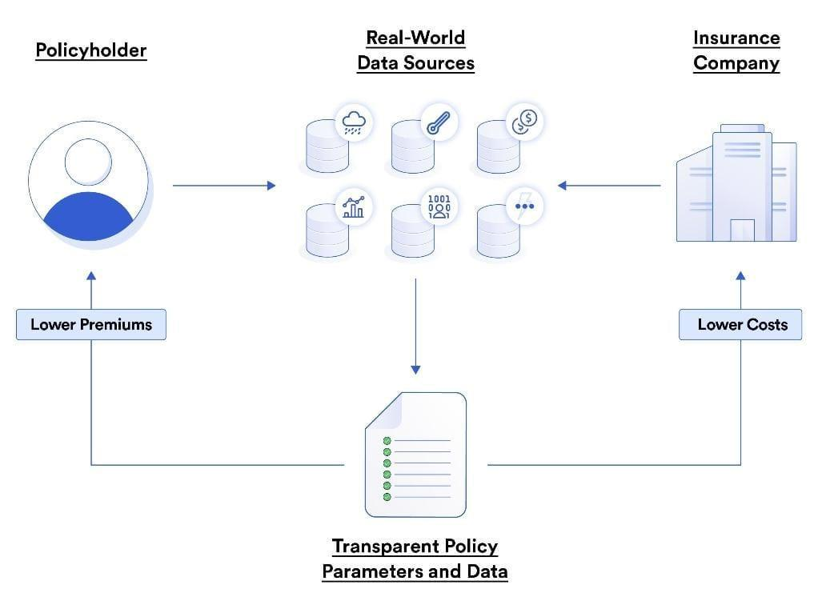

- Database: Storing user data, policies, claims, and historical information.

- APIs: Interfaces for communication with external systems, like weather data providers and payment gateways.

- Machine Learning: Algorithms for risk assessment, fraud detection, and premium calculation

- User Management: Registration, login, and profile management for farmers and agents.

  - Insurance Quoting: The ability to generate insurance quotes based on various factors like crop type, location, and coverage.

  - Policy Management: Tracking and managing policies, including underwriting, endorsements, and renewals.

  - Claims Processing: Handling claims, from submission to approval and payout.

  - Data Analytics: Using data to assess risk, set premiums, and improve the insurance products.

Weather Data: Integrating with weather services to assess the impact of weather on crops.

- Geospatial Data: Utilizing maps and geolocation data to assess the location-specific risks.

- Market Data: Keeping an eye on commodity prices and market conditions affecting crop values.

- Security: Implement strong security measures to protect sensitive data, including encryption, authentication, and authorization.

- Compliance: Ensure compliance with insurance regulations in the target region.

- Scalability: Design the system to handle a large number of users and data over time.

- Reporting and Analytics: Provide tools for generating reports on policies, claims, and financial data.

- Integration: Connect with external financial institutions and payment gateways to manage premium payments and claims payouts.

- Blockchain : Some insurance chains are exploring blockchain technology for transparent and tamper-proof record-keeping.

- Mobile App: Consider a mobile app for agents to assess crops in the
field and process claims efficiently.

- Cloud Infrastructure: Host the solution on a scalable cloud platform for flexibility and reliability.

